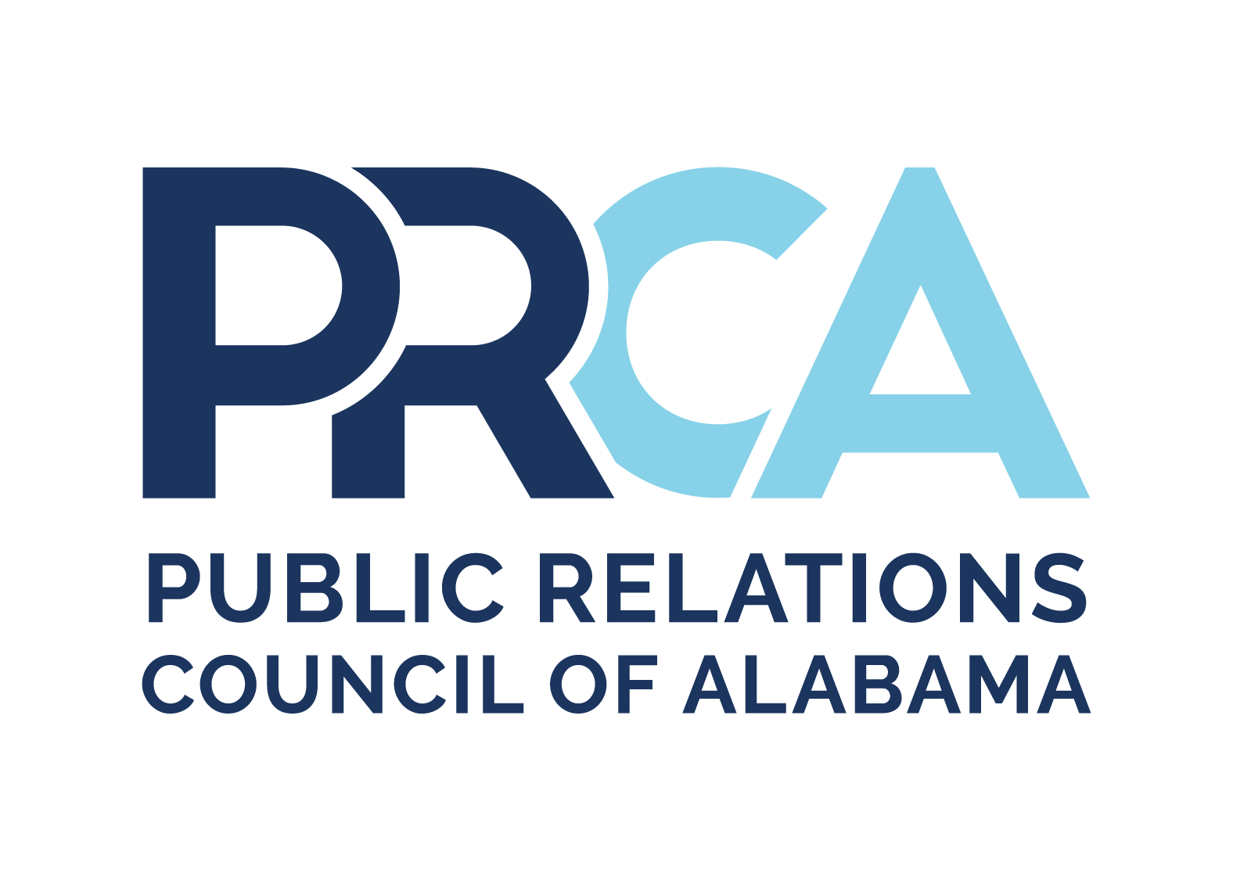
PRCA STUDENT OF THE YEAR GUIDELINES

Eligibility
- The student candidate must be an active member of a PRCA student chapter. Each chapter is allowed only one nominee.
- As of August (one year prior to completion year), the student must have completed enough accredited hours to be classified as a junior in public relations or related course of study.
- The student must have overall GPA of 2.5 on 4.0 scale or 2.0 on 3.0 scale. In major coursework, the student must have at least a 3.0 on 4.0 scale or 2.25 on 3.0 scale.

Section 1: Resume and References (20 points)
- A letter of reference from faculty advisor stating GPA and classification.
- A digital photograph of the nominee.
- One-page resume detailing educational background with a list of communication coursework and public relations work or internship experience.
- Optional: A maximum number of two additional letters of reference (preferably from nominee's chapter and a public relations professional knowledgeable about nominee's ability).

Section 2: Community Service Summary (20 points)
- One-page summary listing the nominee’s participation in organizations and events (nominee should be specific about involvement).
- Optional: one example may be included in this section that demonstrates the results of the nominee’s work with group or event (ex: letter of recognition, materials).
- Additional materials should be removed from the portfolio and not judged.

Section 3: Campus Involvement (20 points)
- One-page summary listing the nominee’s involvement in campus organizations and activities. Summary should include nominee’s memberships, officer positions, activities, recognition, and awards. PRCA activities should be included in this portion of the entry. The summary should document the nominee’s involvement and results of work.
- One example of PRCA involvement must be included in this section (ex: letter of recognition, materials, articles from newsletter or school newspaper, etc.)
- Optional: one example of campus involvement other than PRCA (ex: letter of recognition, materials resulting from nominee’s work, etc.)
- Additional materials should be removed from the portfolio and not judged.

Section 4: Work Samples (20 points total possible)
Public Relations Planning
- One sample of a short- or long-term public relations plan developed by nominee.

Media Relations, Collateral, Other Print or Broadcast Materials
- One sample to demonstrate range and quality of nominee's work (news/feature story, radio or TV PSA, brochures, newsletters, direct mail piece, logo, video or audio script, etc.)

Section 5: Understanding of PR/Future Contributions to Communications Field (20 points)
- Essay of nominee's thoughts on the " the future of public relations in the digital age.”
- Essay should not exceed two double-spaced standard pages or points should be deducted.
- Preference will be given to essays who use nominal assistance from AI. Nominees must acknowledge any specific usage of AI (for example, used AI to outline essay).

Entry Site
Entry is to be submitted through the PRCA Awards website: https://prca.secure-platform.com.

