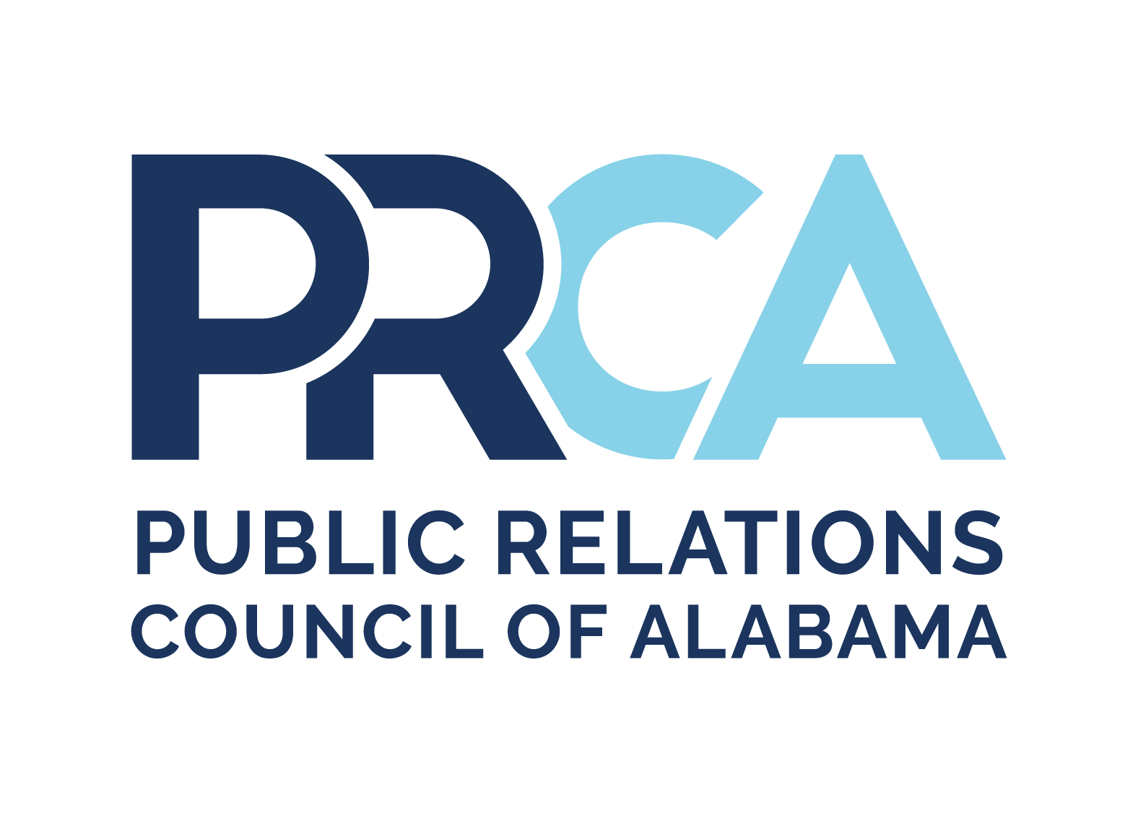
PRCA STUDENT CHAPTER OF DISTINCTION GUIDELINES

Student Chapter of Distinction Guidelines

The Bettie W. Hudgens Student Chapter of Distinction (formerly Chapter of the Year) competition seeks to recognize a student chapter for their collective accomplishments for the year. One chapter is selected based on the following criteria: programs, membership, projects, interaction with sponsoring chapter and the state organization, chapter communication and chapter recognition. The award is named after Bettie Hudgens, a past Mobile chapter member, who was state president in 1988.
Although not required, PRCA encourages each chapter to enter the chapter of the year competition. The tangible benefits of compiling your entry: a report that captures your chapter’s progress and documents the past year’s activities and growth. The tangible benefits of winning: a check for $250, a plaque, and professional recognition.
There is no fee for the Student Chapter of the Year award entry.

Entry Criteria
Specific deadlines will be listed on the PRCA website. Late submissions or submissions in the wrong file format will be disqualified. The entry must be organized according to the following judging criteria:

Judging
When possible, judges for these awards will come from organizations outside PRCA and the four states of the Southern Public Relations Federation (SPRF).

Professional Engagement and Education (25 points)

Interaction with Sponsoring Chapter and State Organization
Explain ways in which your chapter engaged with your sponsoring professional chapter.
Event details (e.g., sponsoring professional chapter educational programs attended; sponsoring professional chapter meetings/events to improve public relations professionalism and standards of current and future practitioners, etc.; student members attending PRCA conference, SPRF conference and/or workshops)
- Goal/objectives
- Target audiences
- Explain how you achieved your objectives by describing:
  - Execution/strategies/tactics
  - Promotional materials used (documentation of use required)

Communications (20 points)
Collateral materials and/or websites produced and distributed exclusively for the chapter. This category is designed to assess the chapter’s efforts to promote the image, professionalism, and general awareness of the public relations profession within its local area.
Describe your chapter’s use of communication materials in the following areas as applicable:
- Regular communication with members
- Event or meeting promotions and announcements
- Communication with non-members (e.g., business community, future student members/, other non-profit organizations, etc.)
- Self-promotion
- Other (press releases, etc.)
- Impact of external publicity

Membership Growth and Involvement (20 points)
State your chapter's membership objectives as they relate to:
- Recruitment
- Retention
- Involvement
How did you achieve these objectives including (but not limited to) the following activities:
- Projects/Programs
- Volunteerism
- Member feedback
- Chapter operations
Describe in detail the results of your membership activities, including membership numbers at the beginning, and membership numbers at the end of the competition period.

Programs and Projects (35 points)
Describe two of your most successful public relations-related and/or community service projects or programs for members, non-members or both. For each program, explain how you achieved your objectives by describing:
- Overall program/project objective
- Event/program details
- Target audience
- Method of promotion
- Average attendance
- Feedback mechanism
- Impact and results (Were objectives achieved?)

