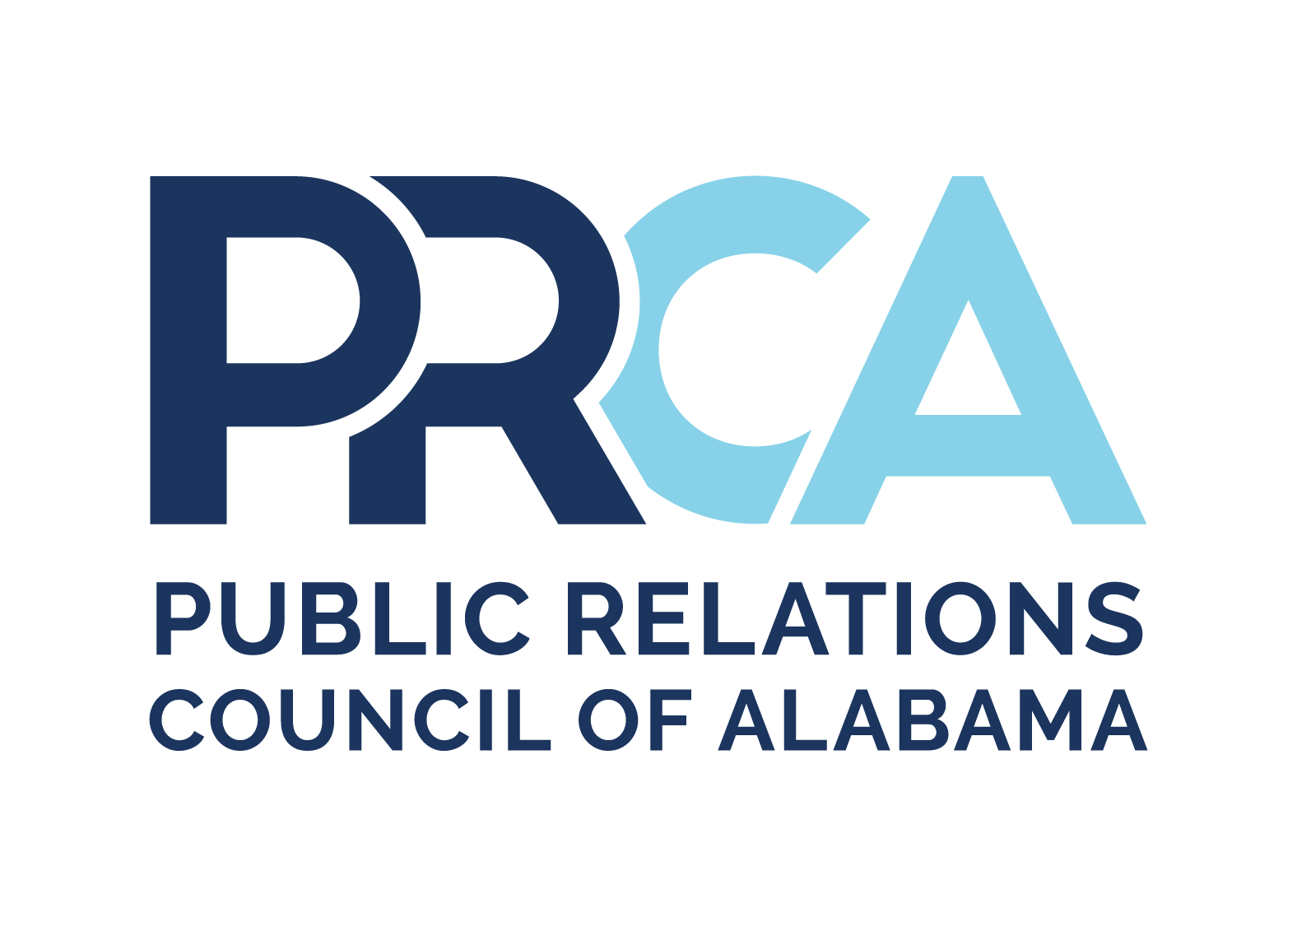
PRCA MEDALLION AWARD COMPETITION STUDENT GUIDELINES

Medallion Guidelines

The Public Relations Council of Alabama's Medallion competition offers all PRCA members the opportunity to have their work recognized and to receive feedback that can facilitate continuous improvement. There are three different tiers with multiple categories, and they are based on the length of time it took for the program, plan, or project.

Tier One: Long-Term Programs & Campaigns (7 months or longer)

- Community Relations and Public Service - Programs seeking to improve relations with or win support of people or organizations in communities with an issue or need.
- Crisis Communications - Programs implemented to deal with an unplanned event requiring immediate response.
- Integrated Communications - Programs exhibiting effective PR strategies and tactics in a creative, integrated campaign.
- Internal Communications - Programs targeted to internal public's such as employees, members, dealers, franchisees, investors.
- Marketing - Programs developed to introduce new products/services or promote existing products/services.
- Media Relations - Programs developed to build relationships with journalists and news organizations or secure ongoing media coverage.
- Public Affairs - Programs developed to influence public policy or legislation.
- Reputation, Issues and Brand Management - Programs designed to enhance the reputation, deal with issues affecting business strategy or enhance the brand of an organization.
- Special Events - Programs or events with special activities where public relations played an integral part.
- Potpourri - Programs that do not fit criteria for other categories.

Tier Two: Short-Term Programs & Campaigns (0-6 months)

- Community Relations and Public Service - Programs seeking to improve relations with or win support of people or organizations in communities with an issue or need.
- Crisis Communications - Programs implemented to deal with an unplanned event requiring immediate response.
- Integrated Communications - Programs exhibiting effective PR strategies and tactics in a creative, integrated campaign.
- Internal Communications - Programs targeted to internal public's such as employees, members, dealers, franchisees, investors.
- Marketing - Programs developed to introduce new products/services or promote existing products/services.
- Media Relations - Programs developed to build relationships with journalists and news organizations or secure ongoing media coverage.
- Public Affairs - Programs developed to influence public policy or legislation.
- Reputation, Issues and Brand Management - Programs designed to enhance the reputation, deal with issues affecting business strategy, or enhance the brand of an organization.
- Special Events - Programs or events with special activities where public relations played an integral part.
- Potpourri - Programs that do not fit criteria for other categories.

Tier Three: Tactical Materials/Projects

- Research and Measurement: reports, white papers, studies, evaluation, communication audits
- Writing: online content (social, blog, web), writing for publications, feature stories, speeches, columns/op-eds, position papers
- Advertising and Publications: One-time special publications, annual reports, magazines, newsletters, brochures, direct
- mail, e-materials, print advertising, billboards
- Social media management: creative and results-oriented use of social media platforms, such as Facebook, Twitter, Instagram, LinkedIn, YouTube, Snapchat, Pinterest, etc.
- Media relations: media materials and activities, such as news releases, media-only events, media kits, online newsrooms, guidebooks, etc.
- Graphics: logos, infographics, organizational identity, photography, signage, kiosks, exhibits, displays, graphic standards, etc.
- Collateral Material: direct mail/e-mail, printed materials, brochures, letterhead packages, apparel, promotional items, etc.
- Audio and Video: videos, commercials, presentations, podcasts, etc.
- Digital: websites, intra-web, mobile applications
- Potpourri
Entry Site
All entries (professional and student) are submitted through the Medallions website: https://prca.secure-platform.com.

Entry Components
- Research / Situation Analysis: Summarize the situation and/or provide information gathered through formal or informal research methods (up to 500 words).
- Planning: Discuss the overall strategy and identify goals, objectives, and key public (up to 250 words).
- Implementation: Outline steps used to achieve the stated objectives; identify the member's specific role in the project (up to 500 words).
- Evaluation: Explain how the success of the program or tool was measured. Report how well it achieved its objective. Include a budget or financial outlay, or if this is a pro bono project, give a value for the hours donated, etc. (up to 250 words).

Student Entry Cost & Deadline
All student entries are $20 each and should be paid for by credit card or check. Payment must be received by the deadline or entries may be disqualified.

Score Sheets
The judging score sheets will help you see how your entry will be evaluated by the judges as they review your entry. Entries receiving a score of 70-79 earn an Award of Merit, 80-89 an Award of Excellence, and 90-100 a Medallion.

Medallion Score Sheet - Tiers 1 and 2

Research (20 pts. possible)
Instructions to entrant: Summarize the situation and/or provide information gathered through formal or informal research methods. Provide information about your organization/client and the impetus for the project.
- Did the practitioner give enough information to understand the project?
- Was the type and quantity of research sufficient to the task?
- Was the analysis of the data reasonable?

Planning (30 pts. possible)
Instructions to entrant: Discuss the overall strategy and identify goals, objectives, and key publics. (Note to judges: Objectives should be: Specific, Measurable, Attainable, Audience-Specific, Relevant, Outcome-Oriented, and Time-Specific.)
- Were measurable objectives set?
- Did the practitioner understand the difference between goals, objectives, and strategies?
- Did the practitioner identify key publics and plan accordingly?
- How well were PR tools utilized? (i.e., writing, organization, editing, design)

Implementation (20 pts. possible)
Instructions to entrant: Outline steps used to achieve the stated objectives. Include timeline and budget information.
- Was the practitioner thorough and detailed in the implementation of tactics/actions?
- Did the practitioner establish and follow a timeline, Gantt chart, or other project management method?
- Is the final project professional, attractive, well-organized, easy to read, eye-catching?

Evaluation (20 pts. possible)
Instructions to entrant: Explain how the success of the program or tool was measured. Report how well it achieved its objective. Include a budget or financial outlay, or if this is a pro bono project, give a value for the hours donated, etc.
- Did the project fulfill its goal and objectives? Were results measurable and measured?
- Do the results reflect program’s purpose or even go beyond expectations?
- Does the entry material support the description of the results?
- Did the practitioner utilize the project budget wisely?
- Did the budget "limit" or "expand" the effectiveness of the project?

Creativity (10 pts. possible)
Did the practitioner use a fresh approach to the project?
- Did the practitioner think outside the box?
- Is color, type, and art used creatively? (If applicable)
- Were limitations cleverly overcome?
- How well do the elements support the concept?

Additional Considerations/Adherence to Submission Criteria (pts. may be subtracted)
At the judges' discretion, points can be docked or entries disqualified based on non-adherence to the guidelines, incomplete entries, inappropriate number/format of support materials, etc.

Medallion Score Sheet - Tier 3

Research (10 pts. possible)
Instructions to entrant: Summarize the situation and/or provide information gathered through formal or informal research methods.
- Was the type and quantity of research sufficient to the task?
- Was the analysis of the data reasonable?

Planning (20 pts. possible)
Instructions to entrant: Discuss the overall strategy and identify goals, objectives, tactics, and key publics which this program was created to achieve.
- How were the objectives specific, measurable, attainable, relevant, outcome-oriented, time-specific and audience-specific?
- Did the practitioner understand the difference between goals, objectives, and strategies?
- Did the practitioner identify key publics and plan accordingly?
- How well were PR tools utilized? (i.e., writing, organization, editing, design)

Implementation (40 pts. possible)
Instructions to entrant: Describe your work and discuss what tactics were used to achieve the stated objectives. Include timeline and budget information. Show how the project was creative.
- Did the practitioner establish and follow a timeline, Gantt chart, or other project management method?
- Is the final project professional, attractive, well-organized, easy to read, eye-catching?

Evaluation (10 pts. possible)
Instructions to entrant: Identify research methods used to evaluate the success of the campaign/project during and after.
- Did the campaign/project achieve its objectives? If project had limitations, how were they overcome? Did the project stay within the timeline and budget? If this was a pro bono project, give a value for the hours donated.
- Were results measurable and measured?
- Do the results reflect its purpose or even go beyond expectations?
- Does the entry material support the description of the results?
- Did the practitioner utilize the project budget wisely?
- Did the budget "limit" or "expand" the effectiveness of the project?

Creativity (20 pts. possible)
Assess whether the practitioner uses appropriate approach to the project.
- Did the practitioner think outside the box?
- Is color, type, and art used creatively? (If applicable)
- Were limitations cleverly overcome?
- How well do the elements support the concept?

Additional Considerations/Adherence to Submission Criteria (pts. may be subtracted)
At the judges' discretion, points can be docked or entries disqualified based on non-adherence to the guidelines, incomplete entries, inappropriate number/format of support materials, etc.

